The transportation problem is a special type of linear programming problem where the objective consists in minimizing transportation cost of a given commodity from a number of sources or origins (e.g. factory, manufacturing facility) to a number of destinations (e.g. warehouse, store). Each source has a limited supply (i.e. maximum number of products that can be sent from it) while each destination has a demand to be satisfied (i.e. minimum number of products that need to be shipped to it). The cost of shipping from a source to a destination is directly proportional to the number of units shipped.
Basic Notation:
- m = number of sources (i = 1 … m)
- n = number of destinations (j = 1 … n)
- c i,j = unit cost of shipping from source i to destination j
- x i,j = amount shipped from source i to destination j
- a i = supply at source i
- b j = demand at destination j

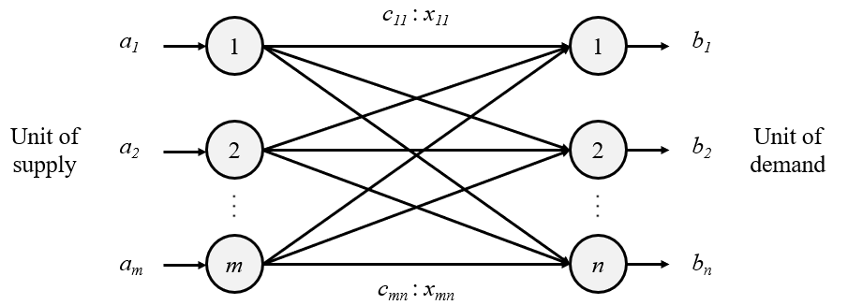

Sources are represented by rows while destinations are represented by columns. In general, a transportation problem has m rows and n columns. The problem is solvable if there are exactly (m+n-1) basic variables.

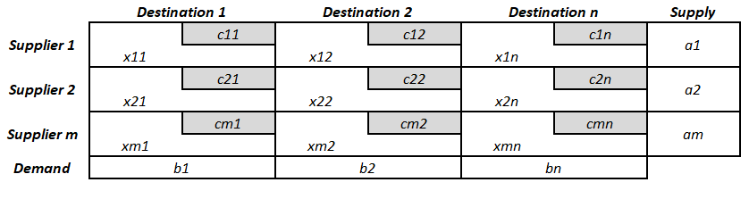

Types of Transportation Problems
There are two different types of transportation problems based on the initial given information:
- Balanced Transportation Problems: cases where the total supply is equal to the total demand.
- Unbalanced Transportation Problems: cases where the total supply is not equal to the total demand. When the supply is higher than the demand, a dummy destination is introduced in the equation to make it equal to the supply (with shipping costs of $0); the excess supply is assumed to go to inventory. On the other hand, when the demand is higher than the supply, a dummy source is introduced in the equation to make it equal to the demand (in these cases there is usually a penalty cost associated for not fulfilling the demand).
In order to proceed with the solution of any given transportation problem, the first step consists in verifying if it is balanced. If it is not, it must be balanced accordingly.

The lpSolve package from R contains specific functions for solving linear programming transportation problems. For the following example, let’s consider the following mathematical model to be solved:
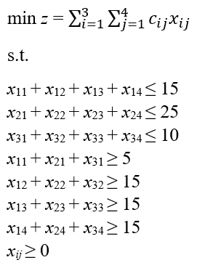
LP Transportation Problem — Mathematical Model

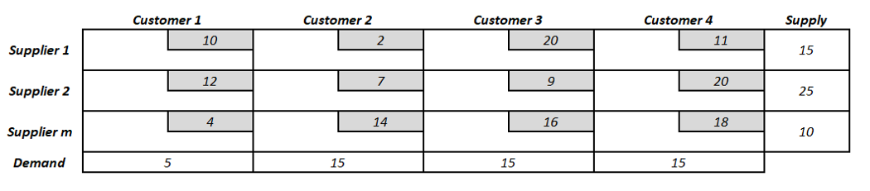

# Import lpSolve package
library(lpSolve)
# Set transportation costs matrix
costs <- matrix(c(10, 2, 20, 11,
12, 7, 9, 20,
4, 14 , 16, 18), nrow = 3, byrow = TRUE)
# Set customers and suppliers' names
colnames(costs) <- c("Customer 1", "Customer 2", "Customer 3", "Customer 4")
rownames(costs) <- c("Supplier 1", "Supplier 2", "Supplier 3")
# Set unequality/equality signs for suppliers
row.signs <- rep("<=", 3)
# Set right hand side coefficients for suppliers
row.rhs <- c(15, 25, 10)
# Set unequality/equality signs for customers
col.signs <- rep(">=", 4)
# Set right hand side coefficients for customers
col.rhs <- c(5, 15, 15, 15)
# Final value (z)
lp.transport(costs, "min", row.signs, row.rhs, col.signs, col.rhs)
# Variables final values
lp.transport(costs, "min", row.signs, row.rhs, col.signs, col.rhs)$solution

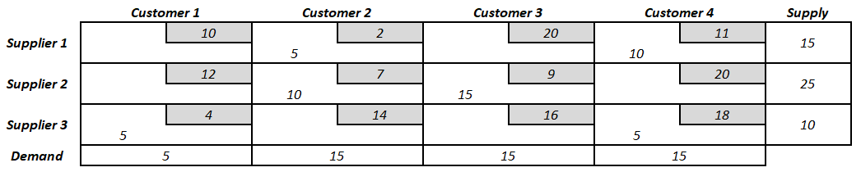

Total transportation cost: $435
The table above shows the optimum combination of products from supplier i to customer j while satisfying the supply and demand constraints. There is no other possible combination of variables that will lead to a lower transportation cost.

What is balanced and unbalanced transportation problem?

When the total number of units available at the supply origins is equal to the total number of items available at the demand destinations, it is termed a balanced transportation problem. If these two values are not equal, it is termed an unbalanced problem.

Types of Transportation problems:
Balanced: When both supplies and demands are equal then the problem is said to be a balanced transportation problem. Unbalanced: When the supply and demand are not equal then it is said to be an unbalanced transportation problem. In this type of problem, eithe r a dummy row or a dummy column is added according to the requirement to make it a balanced problem. Then it can be solved similar to the balanced problem
In real-life, supply and demand requirements will rarely be equal. This is because of variation in production from the supplier end, and variations in forecast from the customer end. Supply variations may be because of shortage of raw materials, labour problems, Transportation Model improper planning and scheduling. Demand variations may be because of change in customer preference, change in prices and introduction of new products by competitors.
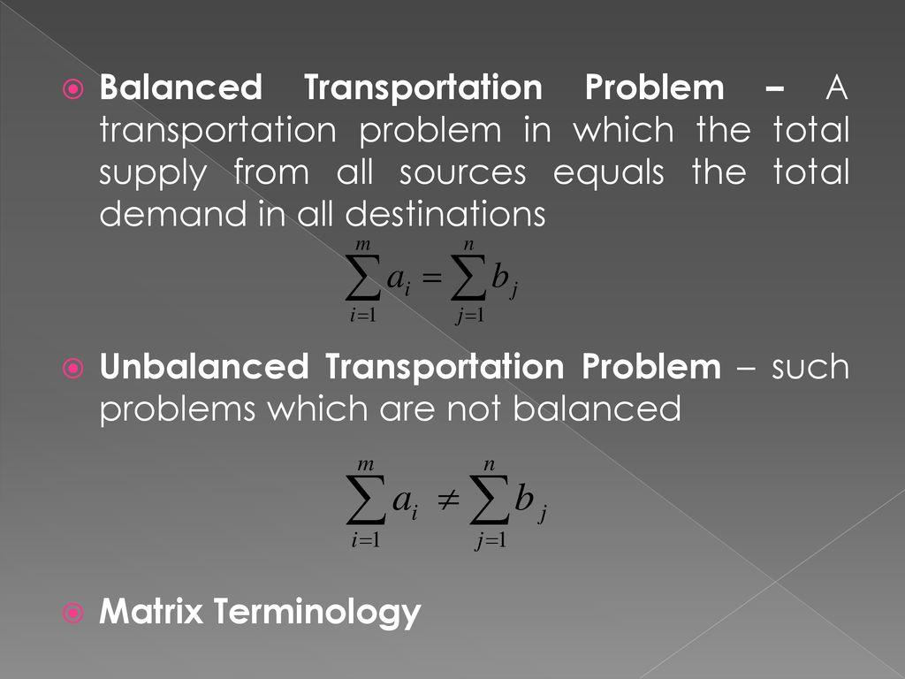
These unbalanced problems can be easily solved by introducing dummy sources and dummy destinations. If the total supply is greater than the total demand, a dummy destination (dummy column) with demand equal to the supply surplus is added. If the total demand is greater than the total supply, a dummy source (dummy row) with supply equal to the demand surplus is added. The unit transportation cost for the dummy column and dummy row are assigned zero values, because no shipment is actually made in case of a dummy source and dummy destination.
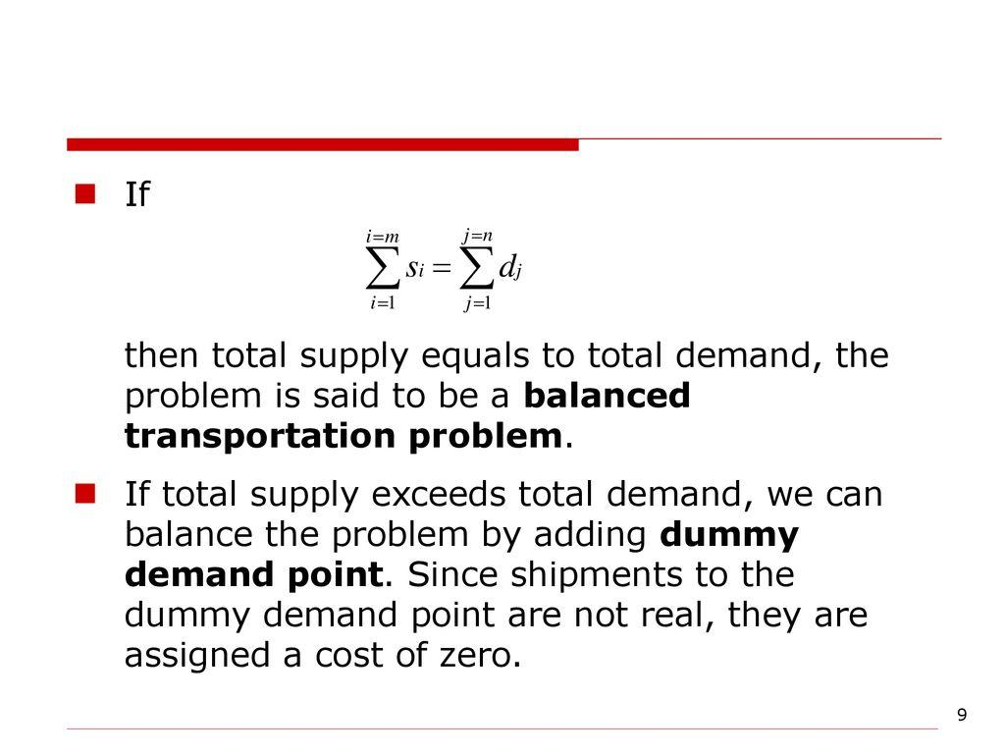

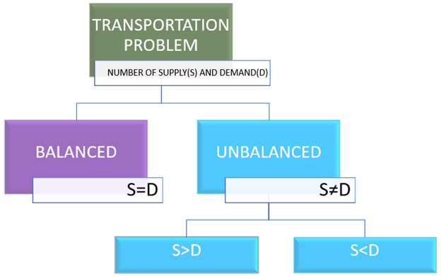

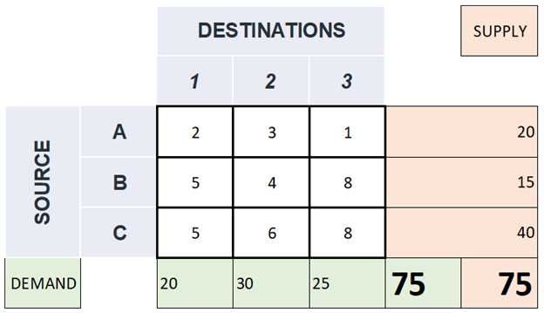
Here,
Total supply=75
Total demand=75
Hence, Total supply= Total demand
The total quantity available at all the sources is equal to the total quantity required the destinations. If they do not match each other, dummy sources or dummy destination are added to make it a standard transportation problem.
There are 2 situations leading to this unbalanced condition
(i). Total Supply> Total Demand
(ii). Total supply< Total demand
(i). Total Supply> Total Demand
I.e., the total quantity available > total quantity required
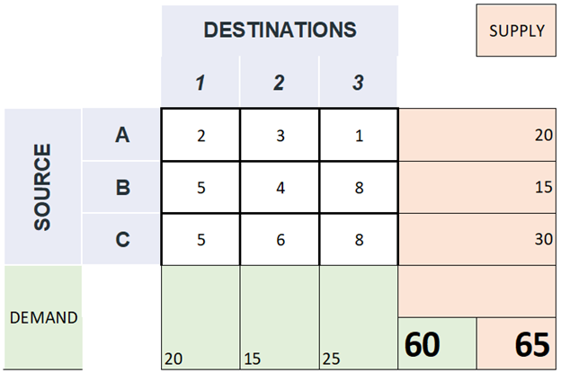
Total supply=65
Total demand=60
Hence, Total supply> Total demand
In such cases, we add a dummy destination giving dummy demand with each cost as zero (0) but dummy demand for the dummy destination as total supply-total demand.
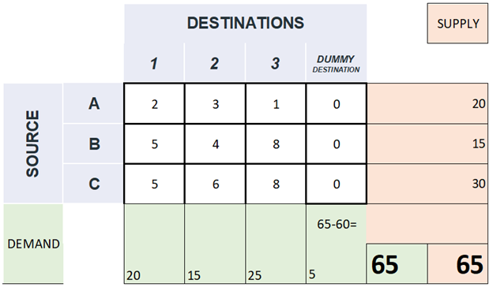
In this example, dummy demand= 65–60=5
Thus, total supply= total demand
(ii). Total supply< Total demand
I.e., the total quantity available <total quantity required
Let’s check the example below.
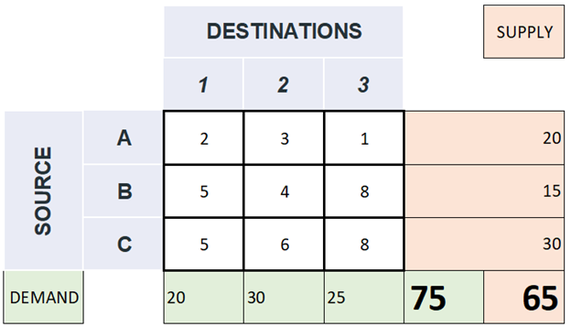

Here,
Total supply=65
Total demand=75
Hence, Total supply<Total demand
In such cases, we add a dummy source giving dummy supply with each cost as zero (0) but dummy supply for the dummy destination as total demand-total supply.
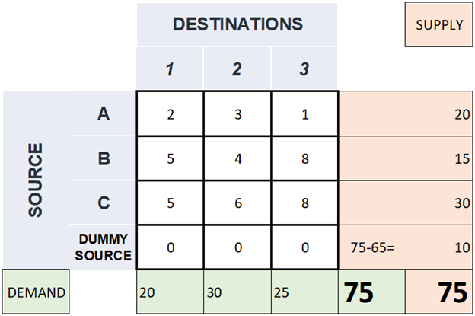
In this example, dummy supply= 75–65=10.
Thus, total supply= total demand
The solution that every problem in transportation looks for is that of the quantity from each source should go to which destination so that all demands at and at the same time the costs are kept to a minimum.

There are different methods available to obtain the initial basic feasible solution. They are:
(1). North-West(N-W) Corner Rule
(2). Least Cost Method (or The Matrix Minimum Method)
(3). Vogel’s Approximation Method [VAM] (or Penalty Method)
Let’s dive into each method.
For that let’s consider an example problem for better understanding.
The question is given below.

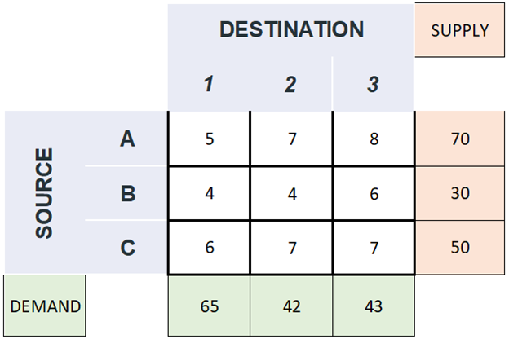
The first step is to make it a standard transportation problem.
For that check whether it is a balanced or unbalanced transportation problem.

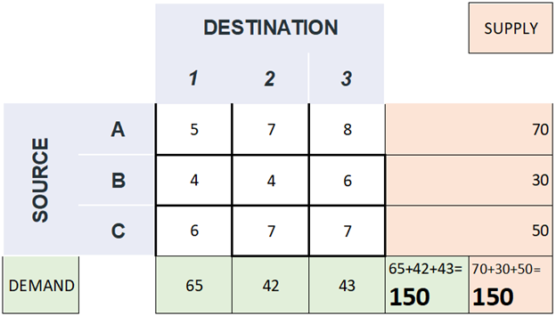
(1). North-West(N-W) Corner Rule
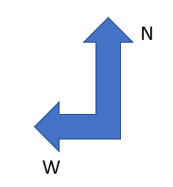
Select North-West Corner cell. i.e., cost of the intersection of 1st row and 1st column. [Here, 5(given in blue)]
Compare the demand and supply of that cell. [Here, 65 and 70 (given in red)]
Allocate the cell with the least value [Here, 65 (given in yellow)]
Subtract the excluded cell with the least value. i.e., the allocated cell vale. [Here, 70–65=5]
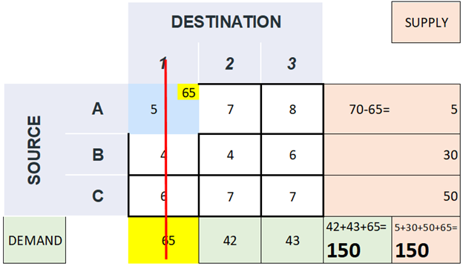

Eliminate the column or row accordingly by striking it off. [Here, the column with destination 1 (marked with red line)]
Always the total demand and supply will remain the same. (You can consider this method to verify whether you are going on the correct path or not.) Because we are allocating the cells with new values in such a way that the total demand and supply will remain the same.
[i.e., Here, 42+43+65=150 (total demand) and 5+30+50+65=150 (total supply)]
Now continue the process with remaining cells.
Again, find the North-West(N-W) cell and do the same steps as given above.
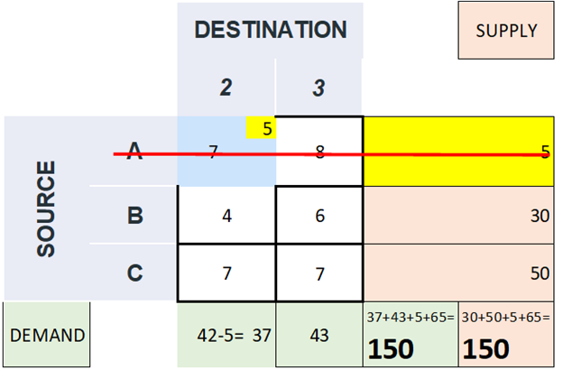
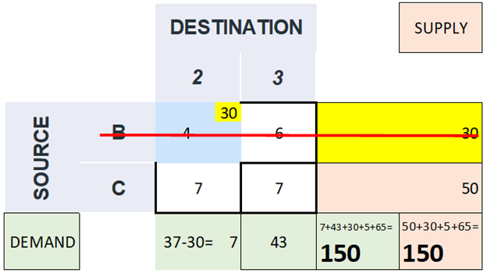
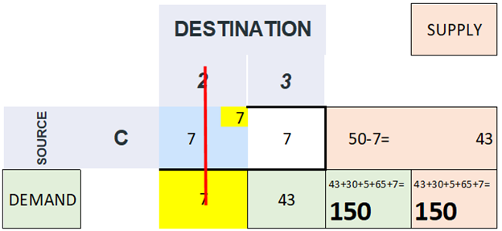
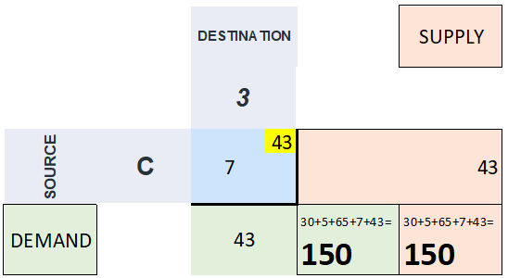
Here, both the demand and supply will be the same which will be further allocated in the remaining single cell. [Here, 43] (This is another method to verify whether all the above steps were correct or not.)
Methods to verify the correctness of the process:
The total demand and supply will remain the same throughout the steps.
In the last step, the single-cell will be allocated with the value in either with demand or supply as both will have the same values.
If the demand and supply have the same values; a tie, you can choose any one of them to allocate the cell making other value zero. (It’s purely user’s choice to decide which one to select
The final table with all allocated cell will be like this.
This gives the initial feasible solution by the N-W Corner method.
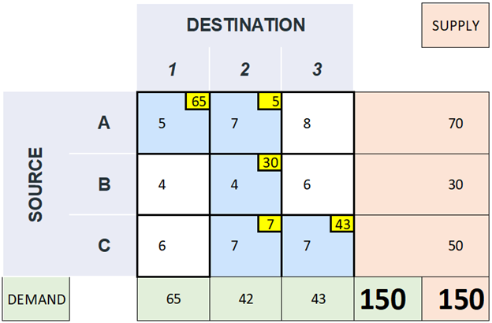

Now let’s calculate the cost associated with these allocations.
To find the same add all the products of all allocated cell values (given in yellow) and the cost of the respective cell (given in blue).
i.e., Total cost=(65x5) +(5x7) +(30x4) +(7x7) +(43x7)
=325+35+120+49+301
=830
Now, let’s understand what we have found out
₹830-represents the total cost involved in moving the commodities.
The path followed is represented by the red arrows as we found by the N-W Corner method.
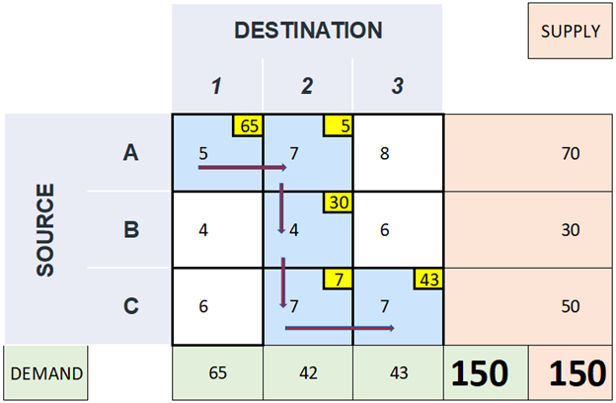
Let’s represent the same in a table
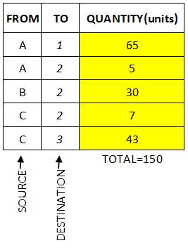

Now continue the process with remaining cells.
Again, find the North-West(N-W) cell and do the same steps as given above.
Let’s see the same in this example.

[image by author]

[image by author]

[image by author]

[image by author]
Here, both the demand and supply will be the same which will be further allocated in the remaining single cell. [Here, 43] (This is another method to verify whether all the above steps were correct or not.)
Methods to verify the correctness of the process:
The total demand and supply will remain the same throughout the steps.
In the last step, the single-cell will be allocated with the value in either with demand or supply as both will have the same values.
If the demand and supply have the same values; a tie, you can choose any one of them to allocate the cell making other value zero. (It’s purely user’s choice to decide which one to select.👍)
The final table with all allocated cell will be like this.
This gives the initial feasible solution by the N-W Corner method.

[image by author]
Now let’s calculate the cost associated with these allocations.
To find the same add all the products of all allocated cell values (given in yellow) and the cost of the respective cell (given in blue).
i.e., Total cost=(65x5) +(5x7) +(30x4) +(7x7) +(43x7)
=325+35+120+49+301
=830
Now, let’s understand what we have found out
₹830-represents the total cost involved in moving the commodities.
The path followed is represented by the red arrows as we found by the N-W Corner method.

[image by author]
Let’s represent the same in a table

the final solution table [image by author]
This may or may not represent the optimal solution for this problem i.e., there may exist other ways of allocating which may give a better solution with a lower total cost.
An optimality test has to be carried out to test whether the obtained answer is optimal. If not, the optimality test leads us to one for a probable improvement.
(2). Least Cost Method (or Matrix Minimum method)
Let’s discuss with the same example.

[image by author]
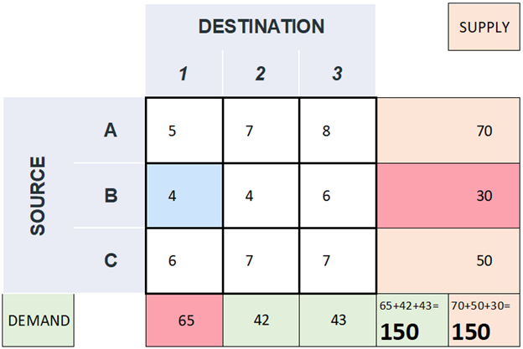
[image by author]
Select the least value among all the costs (given in white). i.e., minimum cost. [Here, 4(given in blue)]
Here, there are two cells with the least cost. It’s purely user’s choice to decide which one to select.
If there are more than 1 cell with the same least cost; a tie, you can choose anyone among them. (It’s purely user’s choice to decide which one to select.👍)
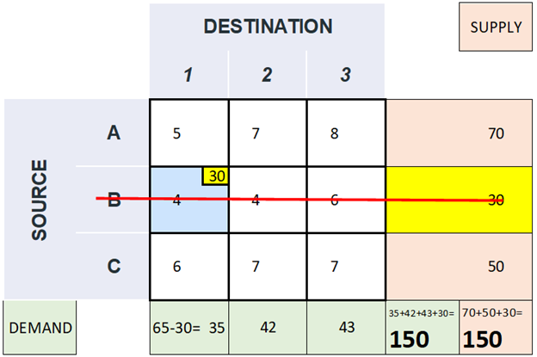
[image by author]
Compare the demand and supply of that cell. [Here, 30 and 65 (given in red)]Allocate the cell with the least value [Here, 30 (given in yellow)]
Subtract the excluded cell with the least value. i.e., the allocated cell value. [Here, 65–30=35]
Eliminate the column or row accordingly by striking it off. [Here, the row with source B (marked with red line)]
Always the total demand and supply will remain the same. (You can consider this method to verify whether you are going on the correct path or not.) Because we are allocating the cells with new values in such a way that the total demand and supply will remain the same.
[i.e., here, 35+42+43+30=150 (total demand) and 70+50+30=150 (total supply)]
Now continue the process with remaining cells.
Again, find the least cost cell and do the same steps as given above.
Let’s see the same in this example.
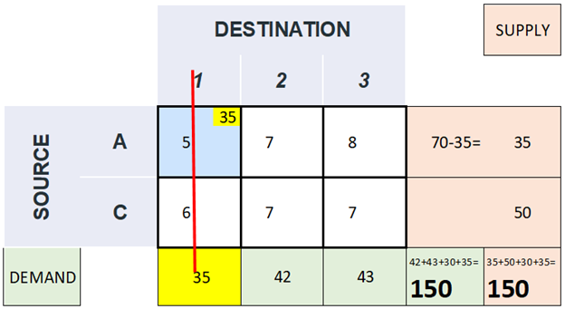
[image by author]
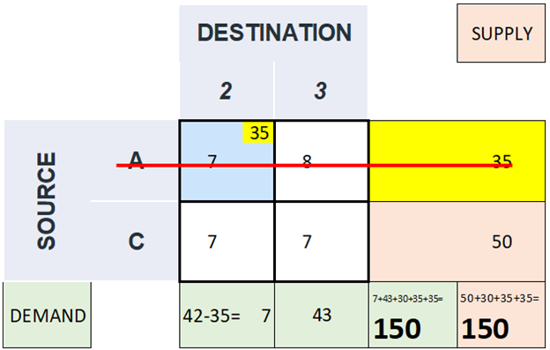
[image by author]
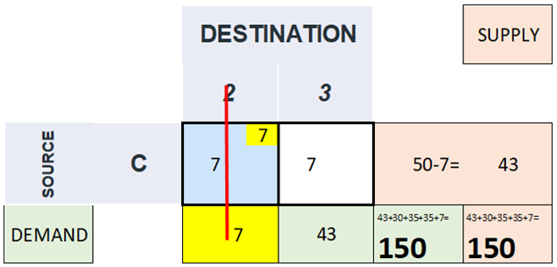
[image by author]
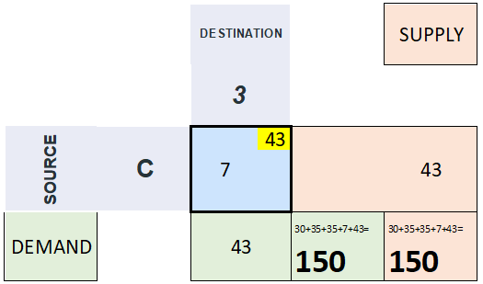
[image by author]
Here, both the demand and supply will be the same which will be further allocated in the remaining single cell. [Here, 43] (This is another method to verify whether all the above steps were correct or not.)
Methods to verify the correctness of the process:
The total demand and supply will remain the same through the steps.
In the last step, the single the cell will be allocated with the value in either with demand or supply as both will have the same values.
If the demand and supply have the same values; a tie, you can choose any one of them to allocate the cell making other value zero. (It’s purely user’s choice to decide which one to select.👍)
The final table with all the allocated cell will be like this.
This gives initially feasible solution by the least-cost method.
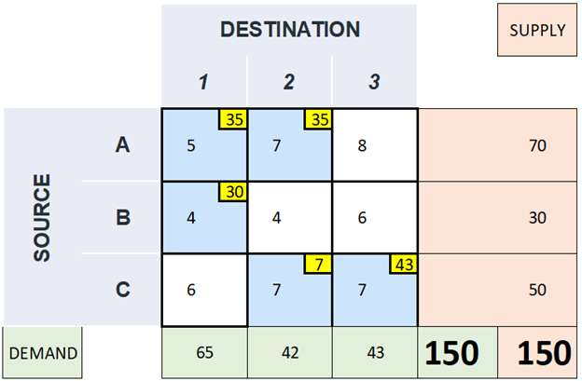
[image by author]
Now let’s calculate the cost associated with these allocations.
To find the same add all the products of all allocated cell values (given in yellow) and the cost of the respective cell (given in blue).
i.e., Total cost=(35x5) +(30x4) +(35x7) +(7x7) +(43x7)
=175+120+245+49+301
=890
Now, let’s understand what we have found out
₹890-represents the total cost involved in moving the commodities.
The path followed is reprinted by the red arrows as we found by the least-cost method.
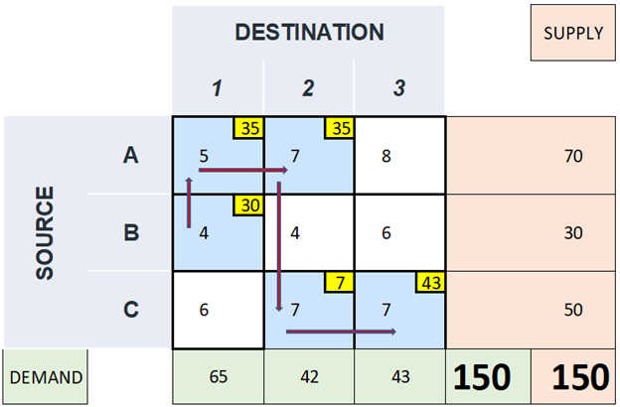
[image by author]
Let’s represent the same in a table.
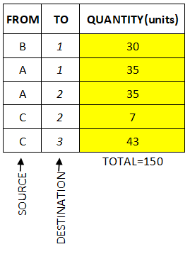
the final solution table [image by author]
This may or may not represent the optimal solution for this problem i.e., there may exist other ways of allocating which may give a better solution with a lower total cost
An optimality test has to be carried out to test whether the obtained answer is optimal. If not, the optimality test leads us to one for a probable improvement.
(3). Vogel’s Approximation Method [VAM] (or Penalty Method)
Let’s discuss with the same example.

[image by author]
Selecting the cost cell to be allocated is not that easy in VAM as if we discussed in the N-W Corner method and least cost cell method. (Chill dude, it’s not that difficult though. 😇But the process is a bit lengthier than before.😅)
In the VAM, we have to first in the differences between the two lowest costs in each row and column. These are known as penalties/ extra costs.
The difference between the two smallest values is considered.
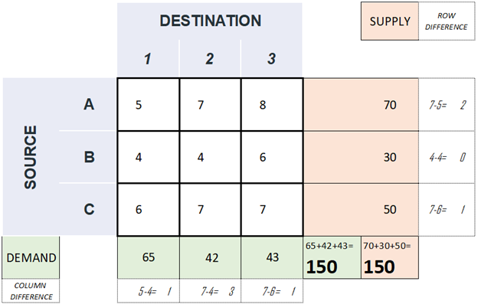
[image by author]
[Here, Penalties= {2,0,1,1,3,1}]
Now find the maximum value among the penalties irrespective of row or column.
[Here, max (Penalties)=3 (given in pink)]
If there is a tie, choose anyone. (It’s purely user’s choice to decide which one to select.👍)
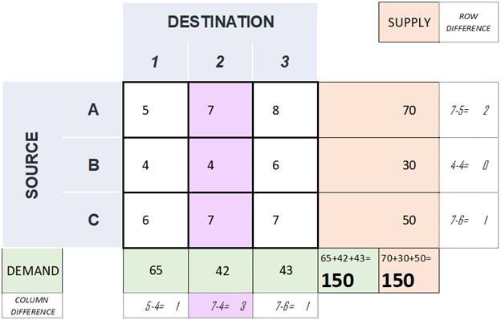
[image by author]
Now, look into the respective row or column accordingly.
[Here, the column (given in pink)]
Select the least value among all the costs (given in pink). i.e., minimum cost. [Here, 4(given in blue in the figure below)]
If there are more than 1 cell with the same least cost; a tie, you can choose anyone among them. (It’s purely user’s choice to decide which one to select.👍)
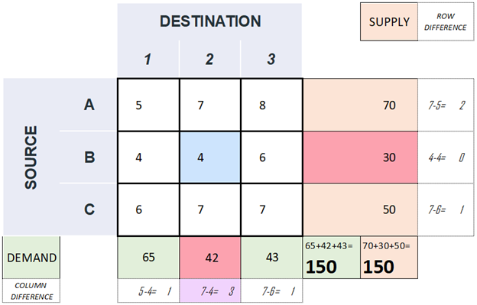
[image by author]
Compare the demand and supply of that cell [Here, 30 and 42 (given in red)]
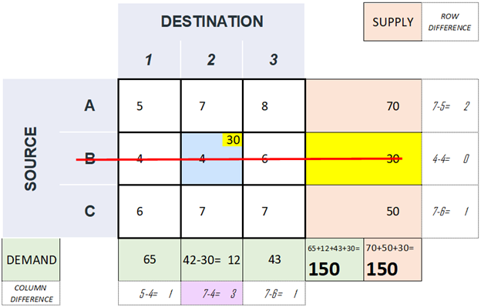
[image by author]
Allocate the cell with the least value [Here, 30 (given in yellow)]
Subtract the excluded cell with the least value. i.e., the allocated cell vale. [Here, 42–30=12]
Eliminate the column or row accordingly by striking it off. [Here, the column with source B (marked with red line)]
Always the total demand and supply will remain the same. (You can consider this method to verify whether you are going on the correct path or not.) Because we are allocating the cells with new values in such a way that the total demand and supply will remain the same.
[i.e., here, 65+12+43+30=150 (total demand) and 70+50+30=150 (total supply)]
Now continue the process with remaining cells.
Again, find the penalty and do the same steps as given above.
Let’s see the same in this example.
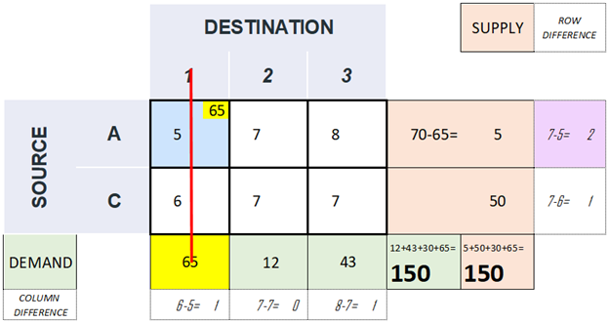
[image by author]
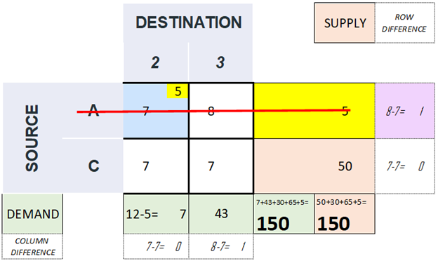
[image by author]
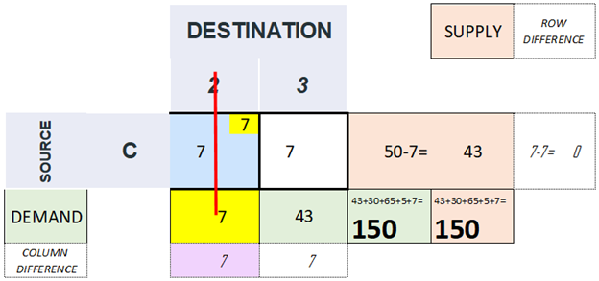
[image by author]
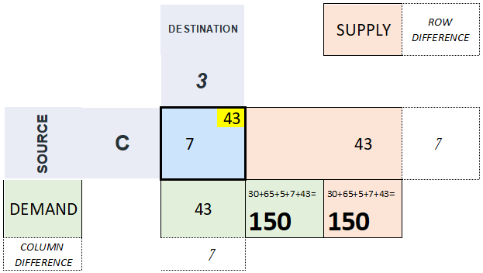
[image by author]
Here, both the demand and supply will be the same which will be further allocated in the remaining single cell. [Here, 43] (This is another method to verify whether all the above steps were correct or not.)
Methods to verify the correctness of the process:
The total demand and supply will remain the same through the steps.
In the last step, the single the cell will be allocated with the value in either with demand or supply as both will have the same values.
If the demand and supply have the same values; a tie, you can choose any one of them to allocate the cell making other value zero. (It’s purely user’s choice to decide which one to select.👍)
The final table with all the allocated cell will be like this.
This gives an initial feasible solution by VAM.

[image by author]
Now let’s calculate the cost associated with these allocations.
To find the same add all the products of all allocated cell values (given in yellow) and the cost of the respective cell (given in blue).
i.e., Total cost=(65x5) +(5x7) +(30x4) +(7x7) +(43x7)
=325+35+120+49+301
=830
Now, let’s understand what we have found out
₹830-represents the total cost involved in moving the commodities.
The path followed is represented by the red arrows as we found by VAM.

[image by author]
Let’s represent the same in a table.

the final solution table [image by author]
This may or may not represent the optimal solution for this problem i.e., there may exist other ways of allocating which may give a better solution with a lower total cost.
An optimality test has to be carried out to test whether the obtained answer is optimal. If not, the optimality test leads us to one for a probable improvement.

- One disadvantage of using the North-West corner rule to find initial solutions to the transportation problem is that it does not take into account cost of transportation. North-west is an easy way to find a solution and works efficiently most of the time. But there isn't any superiority among these methods.
- the North-West Corner Rule is a method adopted to compute the initial feasible solution of the transportation problem. The name north-west corner is given to this method because the basic variables are selected from the extreme left corner. The prerequisite condition for solving the transportation problem is that demand should be equal to the supply.

EXAMPLE MATLAB

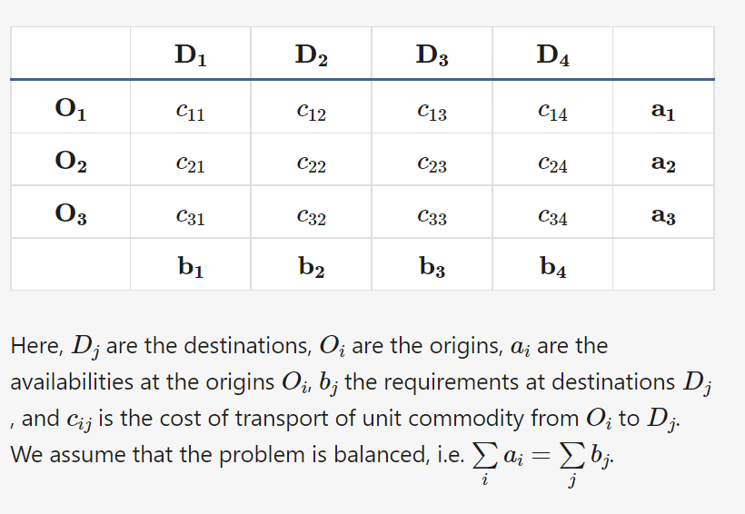
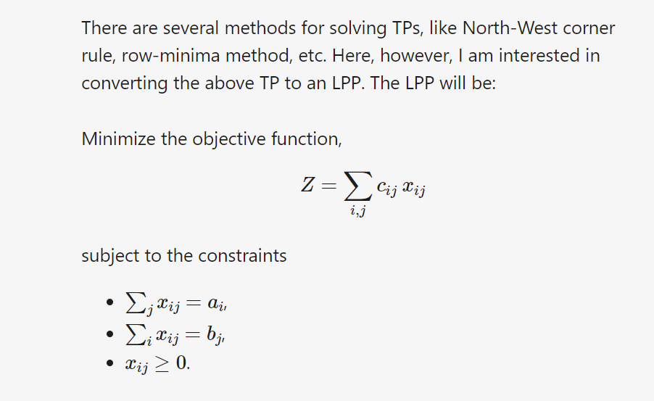
function tp(cost, avb, req)
if sum(avb) ~= sum(req)
exc = MException('tp:unbalancedProblem', ... 'Cannot solve unbalanced problem.');
throw(exc);
end
x = optimvar('x', size(cost, 1), size(cost, 2), 'LowerBound', 0);
z = sum(x .* cost, 'all');
numCons = size(cost, 1) + size(cost, 2);
cons = optimconstr(numCons, 1);
count = 1;
for i = 1:1:size(x, 1)
cons(count) = sum(x(i, :)) == avb(i);
count = count + 1;
end
for i = 1:1:size(x, 2)
cons(count) = sum(x(:, i)) == req(i);
count = count + 1;
end
problem = optimproblem('Objective', z, 'ObjectiveSense', 'min'); problem.Constraints = cons;
show(problem)
problem = prob2struct(problem);
[sol, zval, exitflag, output] = linprog(problem)
end

Formulate the Model IN EXCEL
The model we are going to solve looks as follows in Excel.
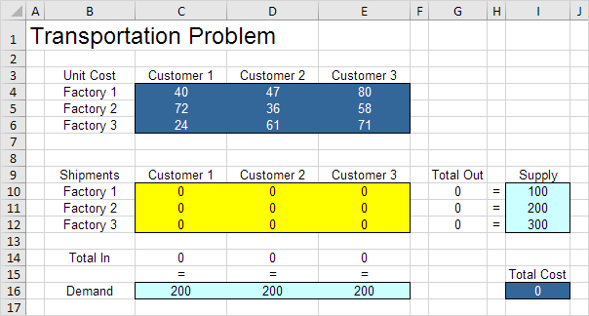
https://www.excel-easy.com/examples/transportation-problem.html

TRANSPORTATION PROBLEM 1

Minimize the costs of shipping goods from factories to customers, while not exceeding
the supply available from each factory and meeting the demand of each customer.
Cost of shipping ($ per product)
 | Destinations
 | Customer 1 | Customer 2 | Customer 3 | Customer 4 | Customer 5
Factory 1 | $1.75 | $2.25 | $1.50 | $2.00 | $1.50
Factory 2 | $2.00 | $2.50 | $2.50 | $1.50 | $1.00
Number of products shipped
 | Customer 1 | Customer 2 | Customer 3 | Customer 4 | Customer 5 | Total | Capacity
Factory 1 | 0 | 0 | 0 | 0 | 0 | 0 | 60,000
Factory 2 | 0 | 0 | 0 | 0 | 0 | 0 | 60,000
Total | 0 | 0 | 0 | 0 | 0
Demand | 30,000 | 23,000 | 15,000 | 32,000 | 16,000
Total cost of shipping |  | $0
Problem
A company wants to minimize the cost of shipping a product from 2 different factories to 5 different customers.
Each factory has a limited supply and each customer a certain demand. How should the company distribute the
product?
Solution
1) The variables are the number of products to ship from each factory to the customers. These are given the
name Products_shipped in worksheet Transport1.
2) The logical constraint is
 | Products_shipped >= 0 via the Assume Non-Negative option
The other two constraints are
 | Total_received >= Demand
 | Total_shipped <= Capacity
3) The objective is to minimize cost. This is given the name Total_cost.
Remarks
This is a transportation problem in its simplest form. Still, this type of model is widely used to save many
thousands of dollars each year.
In worksheet Transport2 we will consider a 2-level transportation, and in worksheet Transport3 we expand this to
a multi-product, 2-level transportation problem.

